Arlie A. Joseph
February 6, 1880 – December 18, 1940

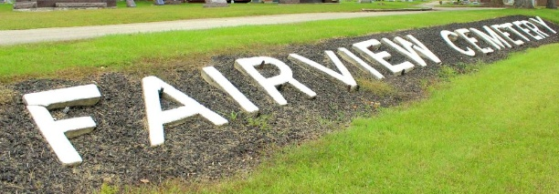
Photo by Tombstoner & Family

FUNERAL HELD FOR ALIN A. JOSEPH
Funeral services were conducted at 2:00 p.m. Sunday at the Bluffton Nazarene church for Alin (Arlie) A. Joseph, 60, who died at the Bluffton hospital late Wednesday. The decedent, father of Mrs. Norman Biberstine, was ill about a week. He was married twice, the second wife, Minnie Collingsworth, died January 24, 1940.
Children surviving from first marriage are Mrs. Will Baker of Dunkirk; Mrs. Harry Lendmen, of Marion; Herschel Joseph, living in Kansas; and Carl Joseph of Michigan.
Those surviving from the second marriage are Mrs. Roscoe Stout, of Vera Cruz; Mrs. Norman Biberstine of Decatur; Mrs. William Bricker of Bluffton; and Woodrow, Helen, Martha and Betty Jean at the county children's home. Four children are deceased: Adele May; Chester; (cut off)...Two brothers also survive, Russell Joseph of Bluffton and George Joseph, of (cut off)

Unknown source
Handwritten date: Monday, December 23, 1940
**

Indiana, U.S., Death Certificates, 1899-2017
Name Arlie A Joseph
Gender Male; Race White
Marital Status Widowed
Age 60y 10m 12d
Birth Date 6 Feb 1880
Birth Place Mercer County, Ohio
Death Date 18 Dec 1940
Death Place Bluffton, Wells, Indiana, USA
Death Registration Date 1940
Father -- Joseph
Spouse Minnie Collinsworth Joseph
Informant Mrs. William Bricker
Burial 12/22/1940 Fairview

