Dale W. Jones
October 28, 1960 – January 15, 2010

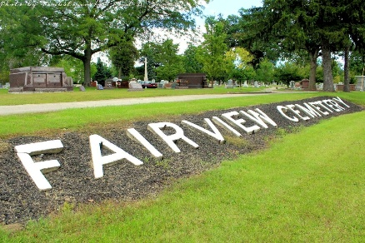
Photo Tombstoner & Family

Dale W. "Billy" Jones, 49, of Huntington, the son-in-law of a Bluffton resident, died at 7:25 p.m. Friday, Jan. 15, 2010, at the Indiana University Medical Center in Indianapolis. He had been ill for two weeks. Mr. Jones had been employed at Sterling Casting for five years. He had been employed at General Aluminum in Huntington since 2004. He resided in Bluffton and Roanoke before moving to Huntington.
He attended Portland High School. He was born Oct. 28, 1960, in Jay County, to James R. Jones and Mabel Elnora Franks Jones. He married Anita M. Wherry Oct. 26, 2001, in Portland; his wife survives.
Also surviving are two stepsons, Jesse Singleton and Jason Singleton, both of Huntington; a brother, Perry Jones of Little Salamonie; an uncle, Bill Franks (companion Alberta Close) of Bluffton; and his mother-in-law, Brenda Baumgartner of Bluffton.
He was preceded in death by his parents and 10 brothers and sisters.
Calling will be from 2 to 8 p.m. Wednesday at the Thoma/Rich, Chaney, and Lemler Funeral Home in Bluffton. The funeral service will be held at 10:30 a.m. Thursday at the funeral home with Pastor Richard Strick officiating. Mr. Jones will be cremated after the funeral service and his ashes will be buried at a later date.

Thoma/Rich, Lemler Funeral Home, Wells County, Indiana

