Sharon L. (Davis) Johnson
April 5, 1953 – January 8, 2004

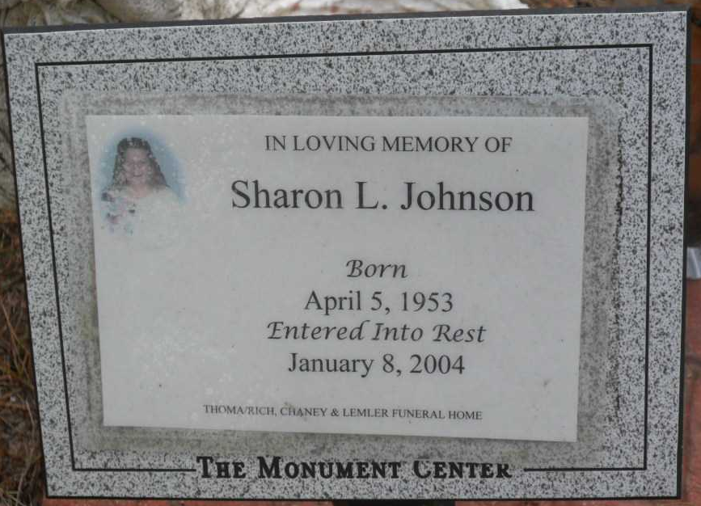
Photo by Pretty Little Grave Seekers
Sharon L. Johnson, 50
A former resident of Bluffton, Sharon L. Johnson, 50, of Columbia City, died at 4:33 p.m. Thursday, Jan. 8, at Parkview Whitley Hospital in Columbia City.
Born April 5, 1953 to Jack W. and Marie Louise Anderson Davis, her marriage in Bluffton Sept. 26, 1975 was to Jeffrey Johnson. She was a housewife and a 1972 graduate of Indianapolis Arlington High School.
In addition to her mother, survivors include a son, Kevin, of Greenwood; a daughter, Mrs. Chris (Heather) Ross of Columbia City; five brothers, Thomas, Rick, Gary and Jeff Davis, all of Indianapolis, and Ray Davis of Norfolk, Va.; two sisters, Kimberly Davis, Gosport, and Pam Haygood of Hitchcock, Texas; and five grandchildren.
She was preceded in death by her father and Erma (Baker) Davis, who raised her.
Services at 10 a.m. Tuesday will be held at Thoma/Rich, Hewitt & Chaney Funeral Home. Officiating will be Rev. James Poling and burial will be in the Fairview Cemetery. Calling from 2 to 8 p.m. Monday and one hour prior to services Tuesday will be held at the funeral home.

News-Banner, Wells County, Indiana
Jan. 9, 2004

