Dorothy Pauline (Hunt) Johnson
October 3, 1920 – November 24, 1995

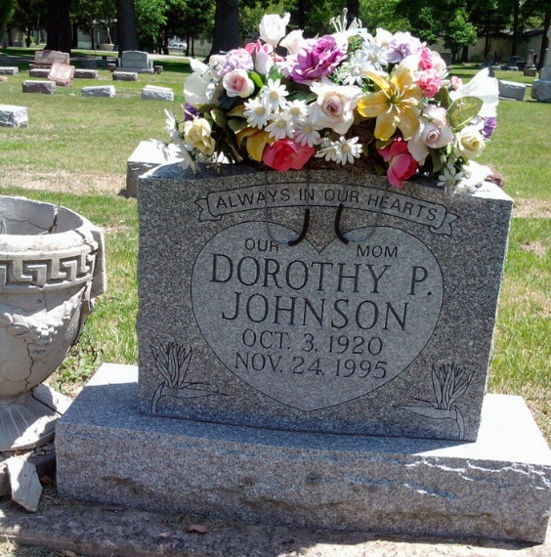
Photo by Thomas Liby

Dorothy Johnson, 75

Mother of Kathy Kumfer of Ossian, Dorothy P. Hunt McDougall Neale Johnson, 75, died Friday at Lutheran Hospital. A native and resident of Fort Wayne, she retired in 1979 from Royal Lace after 17 years.
Surviving in addition to the daughter at Ossian are another daughter, Paulinea "Sandy" Bryant of Fort Wayne; four sons, James William McDougall of Urbana, Ohio; Lynn McDougall of Fort Wayne and Charles McDougall and Ramond McDougall, both of Decatur; 20 grandchildren and 33 great-grandchildren.
A sister, Joan Settle of Fort Wayne and two brothers, Gene Busching of Maryland and Robert Busching of Arizona, also survive.
Services will be at 10 am Tuesday at Elzey & Haggard Home for Funerals in Waynedale, where calling is from 2 to 4 and 6 to 8 pm today. Burial will be in Fairview Cemetery at Bluffton.

Berne Library Heritage Room
Misc. Death Book
Handwritten date - November 24, 1995
**

Indiana, U.S., Death Certificates, 1899-2017
Name Dorothy P Johnson
[Dorothy P Hunt]
Gender Female
Race Caucasian (White)
Marital Status Divorced
Age 75
Birth Date 3 Oct 1920
Birth Place Fort Wayner, Indiana
Death Date 24 Nov 1995
Death Place Fort Wayne, Allen, Indiana, USA
Death Registration Date 1995
Father Byron Hunt
Mother Cecil Mettler
Informant James William McDougall, son
Burial 11/28/1995 Fairview Cemetery
**
Indiana, U.S., Marriages, 1810-2001
Name Dorothy Pauline Hunt
Gender Female
Race White
Age 18
Event Type Marriage Registration (Marriage)
Birth Date 3 Oct 1920
Birth Place Bluffton, Wells, Indiana
Marriage Date 5 Mar 1938
Marriage Place Indiana, United States
Residence Place Fort Wayne
Father Byron Maurice Hunt
Mother Cecil Pauline Mettler
Spouse Charles W Mc Dougall
Officiator Cecil Busching
Page 404
FHL Film Number 002130289

