Lettie Olive (Carnes) Jamison
December 1, 1885 – November 11, 1935

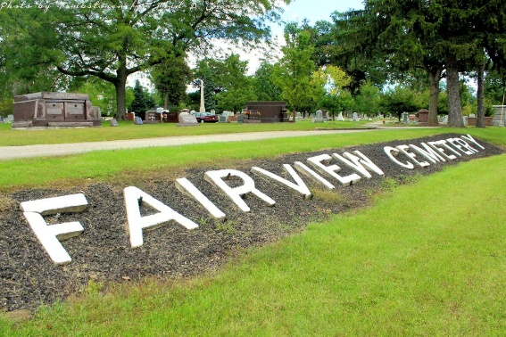
Photo by Tombstoner & Family

MRS. CHAS. JAMISON ANSWERS SUMMONS
DEATH OCCURS MONDAY AFTERNOON AT HER HOME IN CHESTER.
Mrs. Charles Jamison, 49, died Monday afternoon at her home two miles north of Chester Center, after an illness of several months from sugar diabetes. She had been seriously ill the past week.
Mrs. Lettie Olive Jamison was born in Chester Township on Dec. 1, 1885, a daughter of Thomas and Hannah Rogers Carnes. Her marriage took place in Liberty Center on Dec. 2, 1903.
Surviving is the husband; one daughter, Beatrice Wilma Jamison, at home; and two sons, Revie Wilbert Jamison, of Keystone, and Glen Jamison, of Ossian.
Funeral services will be held at 2 o'clock Wednesday afternoon at the Blanche Chapel church, in charge of Rev. I. W. Clark. Burial will be in the Fairview Cemetery, east of Bluffton.
Unknown source
**

Indiana, U.S., Death Certificates, 1899-2017
Name Lettie Olive Jamison
Gender Female
Race White
Marital Status Married
Age 49y 11m 11d
Birth Date 1 Dec 1885
Birth Place Indiana
Death Date 11 Nov 1935
Death Place Chester, Wells, Indiana, USA
Death Registration Date 1935
Father Thomas Carnes
Mother Hannah Rogers Carnes
Spouse Charles Jamison, informant
Burial Fairview Cemtry 11/13/1955

