Glenn William Jamison
January 9, 1909 – January 7, 1964

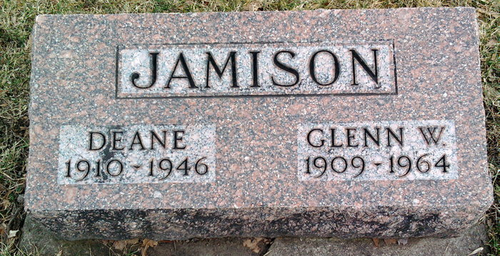
Photo by Annie (Kunkel) Hoffmeier

GLEN JAMISON IS TAKEN BY DEATH
Rites Wednesday for Father of Berne Woman
Glen Jamison, 54, Wells County, died at 3:15 a.m. Sunday in the Blackford County Hospital at Hartford City. He suffered a stroke on Friday and was admitted to the hospital Saturday. Mr. Jamison, a former trustee of Chester Township, was the husband of the former Nora Stauffer, a native of this community. Mr. and Mrs. Jamison resided on R.R. 1, Poneto.
Surviving are the wife; a daughter, Mrs. Eugene Grimm, Berne; a grandson; a brother, Revie Jamison, Bluffton and a sister, Miss Beatrice Jamison, Chester Township, Wells County.
Mr. Jamison was in implement salesman for a Bluffton firm and had delivered some farm machinery near Reiffsburg late Friday when he became ill.
Services will be held at 2 p.m. Wednesday at the Chester Center Church and burial will be in Fairview Cemetery, Bluffton. Friends may call after 7 p.m. today and until noon Wednesday at the Walker Funeral Home, Montpelier.

Berne Witness, Adams County, Indiana
Monday, January 6, 1964
**

Glenn William Jamison from tree Clement/Morrison/Perrigo/McHattie Family Tree
Birth 9 Jan 1909 Wells, Indiana, USA
Marriage 16 Mar 1950 Wells, Indiana, USA
Residence 1950 Wells, Indiana, USA
Death 5 Jan 1964 Hartford City, Blackford, Indiana, USA
Father Charles Jamison (1881-1956)
Mother Lettie O Carnes (1885-1935)
Spouse Clara Deane Markley (Born 1910)
Spouse Nora Stauffer (Born 1910)
4990 People 14 Records 14 Sources

