Charley Jackson Jamison
February 28, 1881 – February 29, 1956

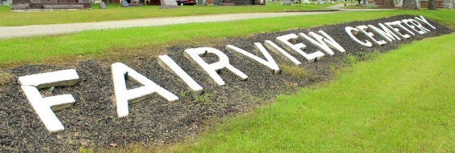
Photo by Tombstoner & Family

Indiana, U.S., Marriages, 1810-2001
Name Charles Jamison
Gender Male
Event Type Marriage Registration (Marriage)
Marriage Date 2 Dec 1903
Marriage Place Indiana, United States
Mother Lizzie Penrod
Spouse Lettie O Carnes
Page 9
FHL Film Number 002318977
**
Charles Jackson Jamison from tree Pattavina/Nolte/lizak 12-24-12
Birth 28 Feb 1881 Wells, Indiana, USA
Marriage 2 Dec 1903 Indiana, USA
Residence 1940 Wells, Indiana, USA
Death 29 Feb 1956 Wells, Indiana, USA
Father Allen JAMISON (1844-1915)
Mother Elizabeth Armanda Penrod (1857-1916)
Spouse Letta Olive Carnes (1885-1935)
51369 People 11 Records 14 Sources

