Clara Deane (Markley) Jamison
September 16, 1910 – March 28, 1946

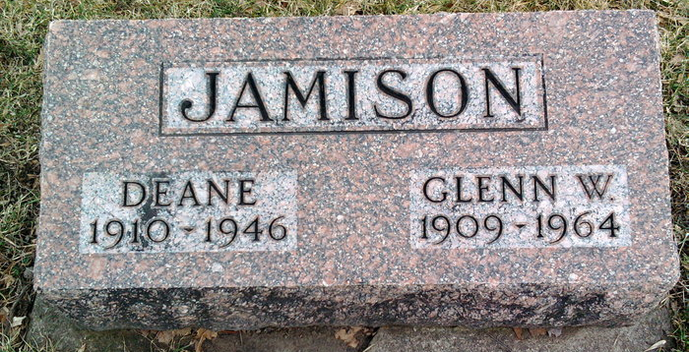
Photo by Annie (Kunkel) Hoffmeier

Indiana, U.S., Death Certificates, 1899-2017
Name Clara Deane Jamison (indexed Olara)
[Clara Deane Jamison]
[Olara Deane Markley]
[Clara Deane Jamison]
Gender Female
Race White
Marital Status Married
Age 35
Birth Date 16 Sep 1910
Birth Place Chester Tp Wells Colorado
Death Date 28 Mar 1946
Death Place Rural, Wells, Indiana, USA
Death Registration Date 1946
Father Oscar Markley
Mother Tillie Bennett
Spouse Glen Jamison, age 40, informant
Burial 3/30/1946 Fairview Cemtry

