William B. Inskeep
September 14, 1928 – August 13, 2009

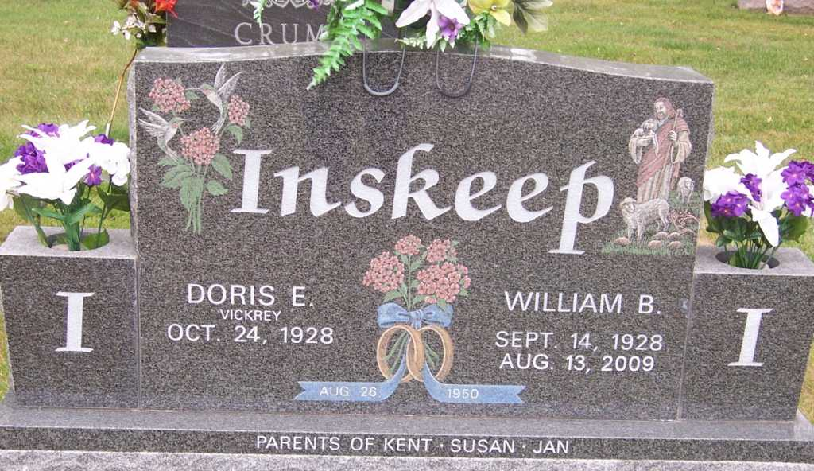
Photo by Pretty Little Grave Seekers
William B. "Bill" Inskeep, 80, Bluffton, died at 4:02 p.m. Thursday, August 13, 2009 in Allen County. Born in Wells County on September 14, 1928 to Charles B. and Mary E. (Reece) Inskeep, he married Doris E. Vickrey on August 26, 1950 in Liberty Center; she survives.
A 1946 graduate of Rockcreek High School, where he was a member of 1946 Wells County Tourney Champions basketball team, Mr. Inskeep retired from NIPSCO after 39 years as a welder and mechanic. He also was a farmer, raising sheep and cattle. He was a member of the Liberty Center United Methodist Church, a former member of the United Steel Workers Union, loved basketball and was an avid Indiana Pacers fan.
Other survivors include a son, Kent (Lana) Inskeep of Bluffton; two daughters, Susan (John) Freds-Dowling and Jan (James) Miller, both of Redlands, Calif.; two sisters, Emojean Brown of Bluffton and Charlene Young of Napoleon, Ohio; nine grandchildren; and six great grandchildren. He was preceded in death by three sisters, Dortha Rochon, Mary Line and Virginia Lieurance; and a grand-daughter, Jordyn Miller.
Services will be held Tuesday at 10:30 a.m. at the Thoma/Rich, Chaney & Lemler Funeral Home with Pastor Devin Cook officiating. Calling hours there are Monday from 2:00 to 8:00 p.m. and Tuesday for one hour prior to the service. Burial will be in Fairview Cemetery.
Preferred memorials are to the Liberty Center United Methodist Church or to the donor's choice.

Thoma/Rich, Lemler Funeral Home, Wells County, Indiana

