Doris E. (Vickrey) Inskeep
October 24, 1928 – November 10, 2019

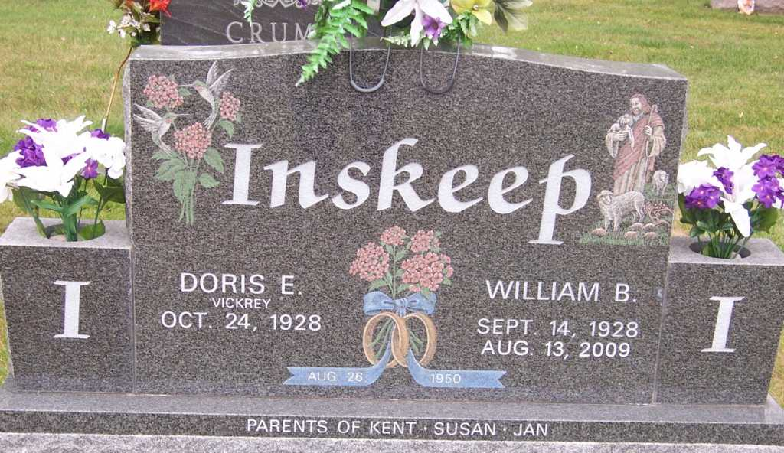
Photo by Pretty Little Grave Seekers
Doris E. Inskeep, 91 of Bluffton passed away on Sunday morning, November 10, 2019, at Christian Care.
She was born on October 24, 1928 in Wells County to Noah & Dessie (Sliger) Vickrey. Doris was born and raised on Noah Vickrey’s family farm west of Bluffton on highway 124. She enjoyed the farm life and they lived there until 2004. A 1946 graduate of Liberty Center High School, Doris worked at the Wells Community Hospital for 30 years, and retired as the treasurer. Even after retirement, Doris enjoyed friendships with several former employees. She was a longtime member of the Liberty Center United Methodist Church, where she taught Sunday School and Bible School for over 20 years.
Doris and William B. “Bill” Inskeep were married on August 26, 1950 at Liberty Center United Methodist Church. They enjoyed traveling the United States, pulling their camper and wintering in California for 19 years upon retirement. He preceded her in death on August 13, 2009.
Survivors include a son, Kent (Lana) Inskeep of Bluffton; two daughters, Susan (John) Freds Dowling of Bluffton and Jan (James) Miller, of Redlands, Calif.; 11 grandchildren; and 11 great grandchildren, along with many nieces and nephews.
She is preceded in death by her parents, husband and a sister, Helen Cargar.
Services will be held 11:00 A.M. on Saturday (November 16, 2019) at the Thoma/Rich, Lemler Funeral Home with Pastor Diane Samuels and Pastor Eugene Vickrey officiating. Calling hours there are Friday from 5:00 to 8:00 p.m. and Saturday for one hour prior to the service.
Burial will be in Fairview Cemetery.
Preferred memorials are to the Liberty Center United Methodist Church.

Thoma/Rich, Lemler Funeral Home, Wells County, Indiana

