Walter R. Huss
March 11, 1882 – June 21, 1956

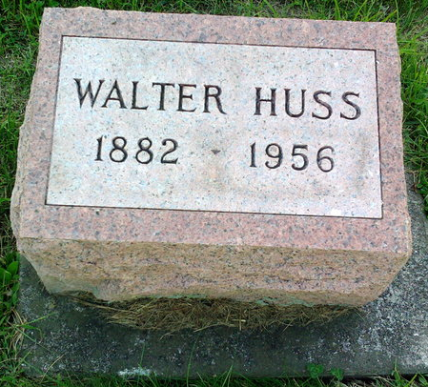
Photo by Thomas Liby

Indiana, U.S., Death Certificates, 1899-2017 (very blurry)
Name Walter R Huss
Gender Male
Race White
Marital Status Divorced
Birth Place Anderson
Death Date 21 Jun 1956
Death Place Sheffield, Indiana, USA
Death Registration Date 1956
Father F?? Florence (illegible)
Mother P?? Florence (looks like Evella Stanhs)
Informant illegible
Burial can't read
**
Michigan, U.S., County Marriage Records, 1822-1940
Name Walter Huss
Gender Male
Age 27
Birth Date abt 1883
Marriage Date 29 Aug 1910
Marriage Place St Joseph, Michigan, USA
Father Hiram Huss
Mother Strong
Spouse Laura Courtney
Film Number 001295530

