Laura (Courtney) Huss
November 1, 1870 – June 16, 1932

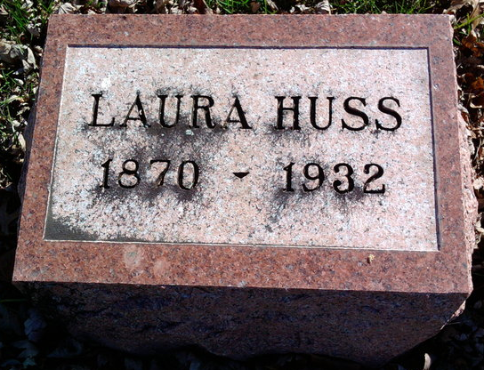
Photo by Thomas Liby

Bluffton, June 17 – Mrs. Laura Courtney Huss, 61, wife of Walter Huss died at 5:30 o’clock last evening at her home at 516 East Ohio Street following an illness of eight months. She was born November 1, 1870, a daughter of Mr. and Mrs. Seth Courtney. She was married to Walter Huss at Centerville, Mich., August 20, 1919. She was a member of the First Baptist Church.
Surviving are the husband, three children by a former marriage, Everett Foreman, August, Kan., William Foreman, Flint, Mich., and Mrs. Andrew Harlan, Sumner, Ill.; an adopted daughter, Pauline Huss; six brothers and sisters, Charles Courtney of Lawrenceville, Ill., Monroe Courtney of Poneto, Mrs. George Stepp of Poneto, Mrs. Mert Grove, Mrs. Vertner Jamison and Mrs. Hugh Dawley of Eliasville, Tex.; a half-sister, Mrs. Byron Roberts and a half-brother, Bert Roberts of Poneto.
Funeral services will be held at 2:30 pm Sunday at the First Baptist Church. Burial in Fairview.

Journal-Gazette, Wells County, Indiana
June 18, 1932, Page 3

