Carolyn A. (Heckman) Humann
March 19, 1946 – April 11, 2017

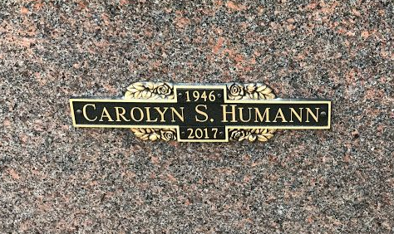
Photo by SMMR

Carolyn S. Humann, 71, of Bluffton passed away at 7:56 a.m. on Tuesday (April 11, 2017) at Bluffton Regional Medical Center in Bluffton.
Carolyn was born on March 13, 1946 in Bluffton, Indiana to William Dale “Pappy” & Clara Bell (Alkire) Heckman. She graduated from Bluffton High School in 1965. She worked as a Home Health Aide and Private Duty Nurse for many years, including working for Family Life Care in Berne.
She enjoyed bowling on the Dale’s Truck & Auto Team for many years. Carolyn also volunteered at the Bluffton / Wells County Animal Shelter for some time. This is where she adopted her favorite dog “Lucky”.
Carolyn is survived by children: Michael L. (Jennifer) Ostrander of Indianapolis, Michele L. Collins and Manfred W. (Jennifer) Humann, of Bluffton along with 10 grandchildren and 8 great-grandchildren. She is also survived by a brother James W. Heckman of Albion and a sister Debbie Heckman of Houston.
She is preceded in death by her parents and siblings; Robert “Bobby” Heckman, Sharon Bouchez, Emma Mae Nave and Nora N. Heckman.
Calling Hours will be held from 1 to 3 p.m. on Thursday (April 13, 2017) at the Thoma/Rich, Lemler Funeral Home in Bluffton. A graveside service will follow the calling hours at the Northridge Mausoleum at Fairview Cemetery, with Jeff Lemler officiating.
Memorials may be made to the Bluffton Fire Department C/O the Bobby Heckman Scholarship Fund.
Thoma/Rich, Lemler Funeral Home, Wells County, Indiana
April 12, 2017

