Maralene M. (Braner) Huffman
February 13, 1928 – February 13, 2016

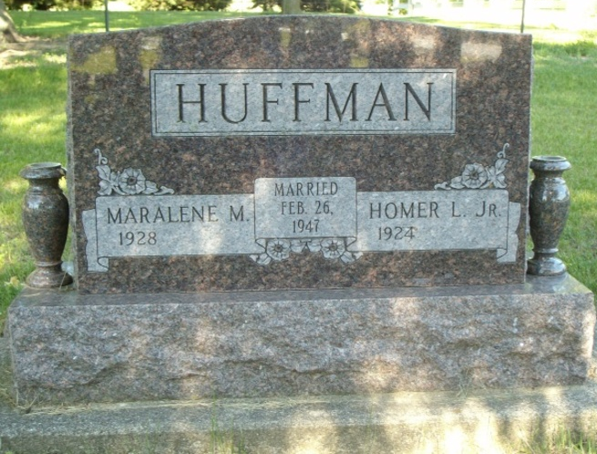
Photo by smalltown

Maralene M. Huffman, 88 of Bluffton passed away at 3:10 a.m. on her 88th birthday on Saturday, February 13, 2016, at Heritage Pointe in Warren.
Mrs. Huffman was born on February 13, 1928 in Wells County to Ellis L. Braner and Gladys May (Hurst) Braner. She attended Pennville High School and worked at Franklin Electric for 23 ½ years in Bluffton. She has been a member of the First Church of Christ in Bluffton since 1957.
On February 26, 1946 at her parents' home in Jay County Maralene and Homer Huffman were married. They shared nearly 70 years together. They have enjoyed traveling, visiting all of the 50 states, and spending their winters in Arizona for 19 years.
She is survived by her husband Homer of Warren a lifetime resident of Bluffton along with a daughter Brenda Sue Sprunger of Uniondale and a daughter in law Linda Huffman of Bluffton. She had five grandchildren; Rob Huffman, Carrie Franze, Abby Maralene Huffman, Breanna Sprunger, Jacoby Sprunger and two great-grandchildren; Isabella Franze and Luke Sprunger.
She is preceded in death by her son Jerry D. Huffman and siblings: Ellis Junior Braner, Pauline Bisel and Marguerite Chrisman.
A service to celebrate Maralene's life will be held at 10:30 on Thursday (February 18, 2016) at the Thoma/Rich, Lemler Funeral Home in Bluffton. Pastor Larry Sprinkle will officiate. Calling hours will be held from 2 p.m. to 8 p.m. on Wednesday at the Thoma/Rich, Lemler Funeral Home in Bluffton and for one hour prior to the service on Thursday. Burial will follow at Fairview Cemetery in Bluffton.
Memorial may be made to First Church of Christ for the Grundy Children's Home.
Thoma/Rich, Lemler Funeral Home, Wells County, Indiana

