Homer Lewis Huffman Jr.
August 22, 1924 – November 12, 2017

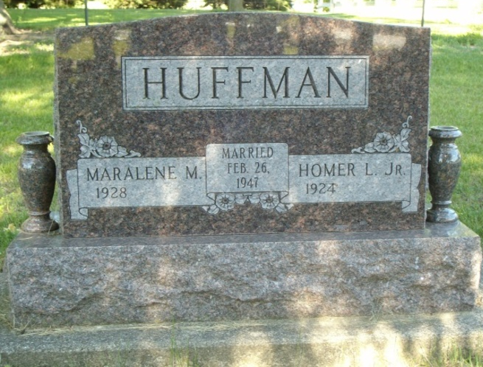
Photo by smalltown

Homer L. Huffman, Jr., 93 of Bluffton passed away Sunday evening, November 12, 2017, at Heritage Pointe in Warren.
Mr. Huffman was born on August 22, 1924 in Wells County, Indiana to Homer L. Huffman, Sr. & Abigail (Bain) Huffman. He graduated from Poplar Grove High School and entered the United States Army to serve his country for 2 years from 1944 to 1946. Homer worked at Franklin Electric for 32 ½ years, retiring in 1985 along with farming with Dave Prible for over 25 years. He was a founding member of the First Church of Christ in Bluffton and has attended since 1957.
On February 26, 1946 at his in-laws home in Jay County, Homer and Maralene M. (Braner) were married. They shared nearly 70 years together before she preceded him in death on February 13, 2016. Together, they enjoyed traveling, visiting all of the 50 states, and spending their winters in Arizona for 19 years. He was loved by many and knew no strangers. He loved to go fishing and jeeping in the mountains of Arizona.
Homer is survived by his daughter Brenda Sue Sprunger of Uniondale and a daughter-in-law Linda Huffman of Bluffton. He had five grandchildren; Rob Huffman, Carrie Franze, Abby Huffman, Breanna Sprunger, Jacoby Sprunger and two great-grandchildren; Isabella Franze and Luke Sprunger. He is also survived by a brother, Forrest “Woody” Eugene Huffman of Fort Wayne and a sister Marge A. Ruel of Bluffton.
He is preceded in death by his wife and his son Jerry D. Huffman.
A service to celebrate Homer’s life will be held at 2:00 P.M. on Thursday (Nov. 16, 2017) at the Thoma/Rich, Lemler Funeral Home in Bluffton. Pastor Gerald O. Moreland will officiate. Calling hours will be held from 3 p.m. to 7 p.m. on Wednesday at the Thoma/Rich, Lemler Funeral Home in Bluffton and for one hour prior to the service on Thursday. Burial will follow at Fairview Cemetery in Bluffton with military honors by the American Legion Post #111 of Bluffton and the United States Army Honor Guard.
Memorial may be made to First Church of Christ for the Grundy Children’s Home.
Thoma/Rich, Lemler Funeral Home, Wells County, Indiana
November 13, 2017

