Jason Lee Howe
January 20, 1976 – January 20, 1976

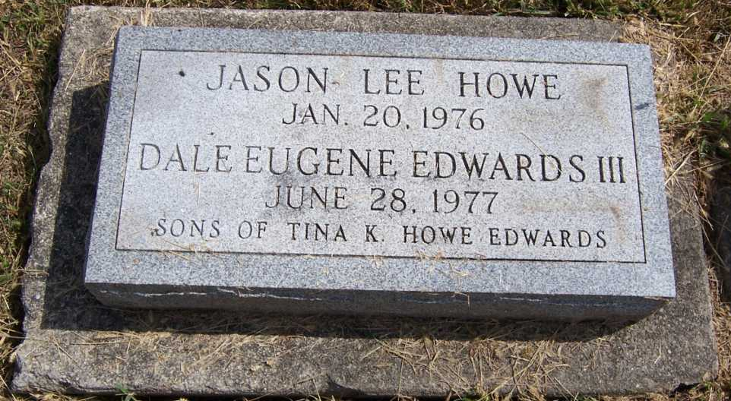
Photo by Pretty Little Grave Seekers

Graveside services for Jason Lee Howe, infant son of Tina K. Howe of 1418 Garden Club Drive, will be at 10 am Thursday in Fairview Cemetery, Bluffton.
The child was stillborn at 12:50 am yesterday in Lutheran Hospital.
Also surviving are grandparents, Mr. and Mrs. Clyde Howe, Fort Wayne and a great-grandmother, Mrs. Emma Dishong, Ossian.
Arrangements are by Chalfant-Perry-Klaehn Funeral Home.

Journal-Gazette, Allen County, Indiana
January 23, 1976, Page 10A

