Alva Householder
October 23, 1868 – May 7, 1940

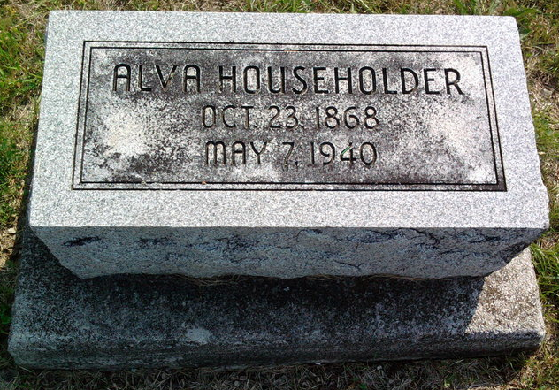
Photo by Thomas Liby

BLUFFTON MAN DIES OF BURNS

Bluffton, May 7 – Alva Householder, 71, died at the county hospital here at 10:30 am today of infection and complications that developed from burns on one of his legs. One leg was amputated at the hospital here a few weeks ago when efforts to check the infection had proven futile. Householder suffered the burns when one of the legs of his trousers caught fire on a bonfire. He was a laborer and was never married.
Surviving are a brother, Charles of Bluffton, and a sister, Mrs. Ella Leist of Liberty Center.
Funeral services will be held at 10:30 am Thursday at the Thoma Funeral Home in charge of Rev. E. R. Garrison. Burial will be in Fairview Cemetery.

Journal-Gazette, Allen County, Indiana
May 8, 1940
**

Indiana, U.S., Death Certificates, 1899-2017
Name Alva Householder
Gender Male; Race White
Marital Status Single
Age 71y 5m 14d
Birth Date 23 Oct 1868; Birth Place Fairfield County, Ohio
Death Date 7 May 1940; Death Place Bluffton, Wells, Indiana, USA
Father Andrew Householder
Mother Catherine Jones
Informant Mrs. Oliver Cole, Bluffton, IN
Burial 5/9/1940 Fairview Cem

