Richard L. Houdyshell
September 15, 1923 – March 26, 1999

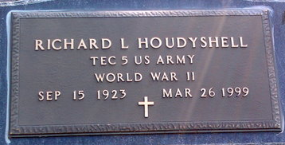
Photo by Thomas Liby

Indiana, U.S., Death Certificates, 1899-2017
Name Richard L. Houdyshell
Gender Male
Race White
Marital Status Divorced
Age 75
Birth Date 15 Sep 1923
Birth Place Wells County, Indiana
Death Date 26 Mar 1999
Death Place Marion, Grant, Indiana, USA
Death Registration Date 1999
Father Jake Houdyshell
Mother Florence Jones
Informant Connie Medsker, daughter
Burial 3/29/1999 Fairview Cemetery
**
Indiana, U.S., Marriage Certificates, 1960-2012
Name Richard L Houdyshell
Gender Male
Race White
Marriage Age 22
[22]
Birth Date 15 Sep 1923
Birth Place Wells, Indiana
Marriage License Date 8 Jun 1946
Marriage Date 9 Jun 1946
Marriage Place Wells, Indiana, USA
Residence Place Bluffton, Indiana
Father Jake Houdyshell
Mother Florence Jones
Spouse Lanta Alice Gehrett
Officiator Ernest Stengel

