Frances Ward Hogg
May 6, 1880 – January 11, 1940

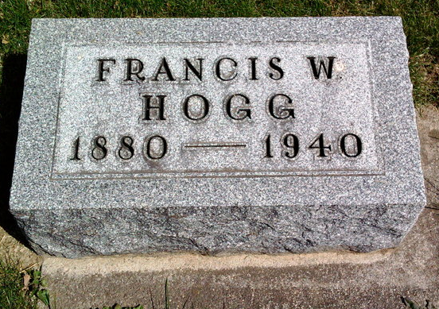
Photo by Thomas Liby

Howe, Jan. 11 - Francis W. Hogg, 60, died early today at his home here after an illness of two years. He was formerly a resident of Bluffton.
Surviving are the widow, Mrs. Anna Hogg; three sons, Milford and Robert Hogg of Fort Wayne and George Hogg at home; one daughter, Anna Ruth Hogg of Fort Wayne and one brother, John Henry Hogg of near Bluffton.
Funeral services will be held Saturday at 10 am at the Shoup Funeral Home here with Rev. Walter G. Pitkin officiating and at 2 pm at the First Evangelical and Reformed Church at Bluffton with Rev. B. E. Reesnyder of Fort Wayne and Rev. Matthew Worthman of Bluffton officiating. Burial will be in Fairview Cemetery at Bluffton.

Journal-Gazette, Allen County, Indiana
January 12, 1940
**

Indiana, U.S., Death Certificates, 1899-2017
Name Francis W Hogg
Gender Male; Race White
Marital Status Married
Age 59y 8m 5d
Birth Date 6 May 1880
Birth Place Bluffton, Wells County, Indiana
Death Date 11 Jan 1940
Death Place Howe, LaGrange, Indiana, USA
Father James Hogg b. Ireland
Mother Elizabeth Torens b. Ireland
Spouse Anna Grace Baker Hogg, informant
Burial 1/13/1940 Fairview, Bluffton

