Anna Grace (Baker) Hogg
October 20, 1883 – December 6, 1967

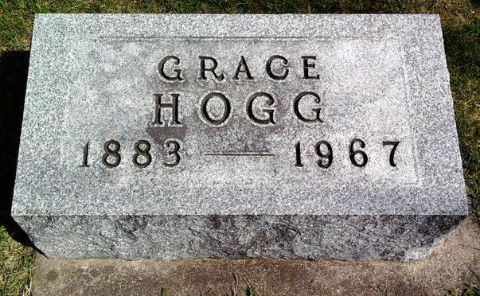
Photo by Thomas Liby

Indiana, U.S., Death Certificates, 1899-2017
Name Anna Grace Hogg
[Anna Grace Baker]
Gender Female
Race White
Marital Status Widowed
Age 84
Birth Date 20 Oct 1883
Birth Place Howard County, Indiana
Death Date 6 Dec 1967
Death Place Fort Wayne, Allen, Indiana, USA
Death Registration Date 1967
Father James A Baker
Mother Caroline Gommell
Informant Anna Ruth Clements, daughter
Burial 12-9-1967 Fairview Cemetery

