William Hoch
August 8, 1869 – May 14, 1939

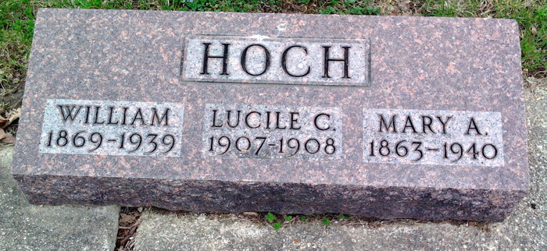
Photo by Thomas Liby

Indiana, U.S., Death Certificates, 1899-2017
Name William Hoch (indexed as Hock)
Gender Male
Race White
Marital Status Married
Age 69y 9m 6d
Birth Date 8 Aug 1869
Birth Place Indiana
Death Date 14 May 1939
Death Place Bluffton, Wells, Indiana, USA
Death Registration Date 1939
Father William Hoch b. Germany
Mother Christine H. b. Germany
Spouse Alice Hixon Hock, informant
Burial Fairview 5/16/1939

