Mary Alice (Hixon) Hoch
April 25, 1863 – Jun 4, 1940

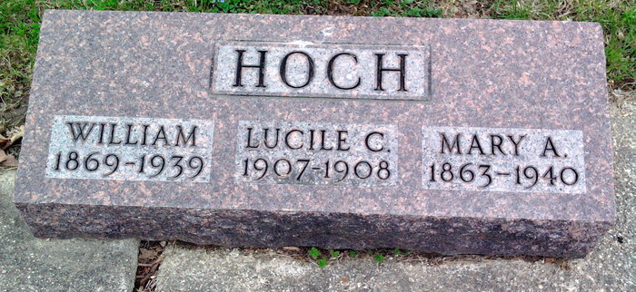
Photo by Thomas Liby

HOCH

Bluffton, June 4 – Mrs. Alice Hixon Hoch, 77, died today at the Wells County Hospital here of a cerebral hemorrhage, following a serious illness of eight days. She was the widow of William Hoch and formerly resided in Fort Wayne.
Surviving are a daughter, Mrs. E. S. Downie of Fort Wayne and a brother, Charles Hixon, of Bluffton.
The body was removed to the Thoma Funeral Home, where funeral services will be held at 4 pm Thursday in charge of Rev. Russell Palmer of the Church of Christ. Burial will be in Fairview Cemetery.

Journal-Gazette, Allen County, Indiana
June 5, 1940
**

Indiana, U.S., Death Certificates, 1899-2017
Name Alice Hixon Hoch
[Alice Hixon Hixon]
Gender Female
Race White
Marital Status Widowed
Age 77y 1m 11d
Birth Date 25 Apr 1863
Birth Place Wells County, Indiana
Death Date 4 Jun 1940
Death Place Bluffton, Wells, Indiana, USA
Death Registration Date 1940
Father James Hixon b. VA
Mother Mary Martin b. VA
Spouse William Hoch
Informant Mrs. E G Davies, Ft. Wayne
Burial 6/6/1940 Fairview Cem.

