Pamela A. (Hughes) Higdon
September 19, 1959 -

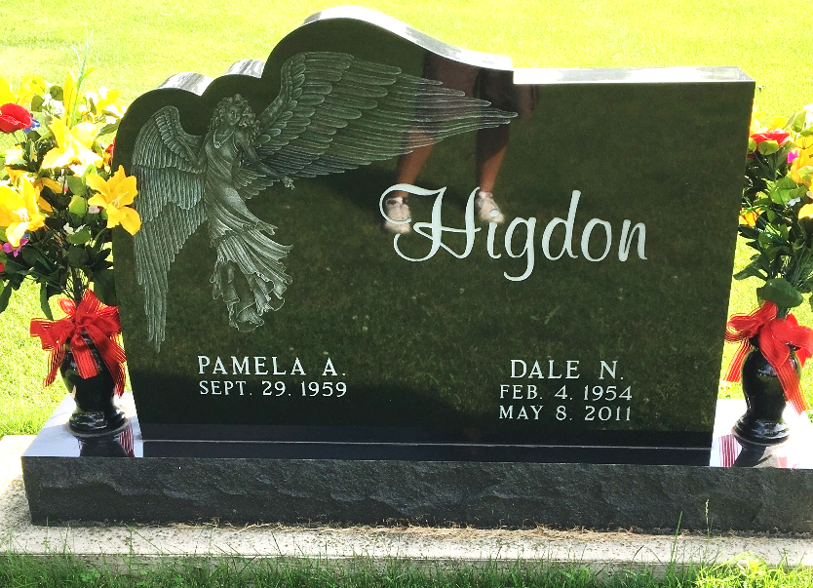
Photo by Scott Shoup

