Dale Nolan Higdon
February 2, 1954 – May 8, 2011

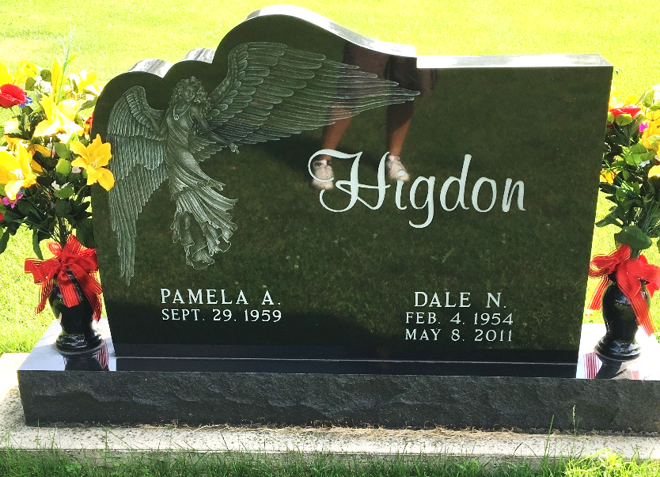
Photo by Scott Shoup

Dale Nolan Higdon, 57, of Markle passed away at 8:30 p.m. Sunday, May 8, 2011 at his home. He was born in Muncie, Indiana on February 4, 1954 to Calvin and Thomasine (Brannon) Higdon, they preceded him in death. Dale married Pamela A. (Hughes) on May 19, 1979 in Bluffton, she survives.
Dale owned and operated County Line Towing in Markle for 22 years. He has resided in Markle for the past 20 years. He previously lived in Huntington and Bluffton.
Dale is also survived by two daughters, Christy Higdon of Bluffton, Ashley Higdon of Markle; two brothers, David Higdon of Muncie, Calvin Higdon of Bluffton; a sister, Vicki Hardin of Markle; one half-sister, Deanna Mensen of Lafayette, Indiana; two grandsons, Jacob Burkhart of Bluffton, Braden Burkhart of Bluffton; one granddaughter, Autumn Burkhart of Bluffton.
Dale was preceded in death by a son, Dale N. Higdon, Jr. on January 19, 1999. He was also preceded in death by a sister Gwen Higdon.
Calling hours are 3:00 to 8:00 p.m. Wednesday, May 11, 2011 at Thoma/Rich, Chaney and Lemler Funeral Home in Bluffton. Funeral service is at 10:30 a.m. Thursday, May 12, 2011 at the funeral home with Pastor Donald Marlowe officiating. Burial will be at Fairview Cemetery. Preferred memorials are to the Bluffton Church of God Food Pantry.

Thoma/Rich, Lemler Funeral Home, Wells County, Indiana

