Robert D. Heckman
December 1, 1947 – November 13, 2003

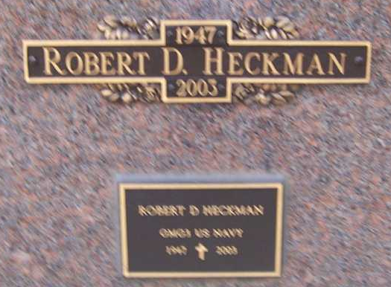
Photo by Pretty Little Grave Seekers

Robert D. "Bob" Heckman, 55, Bluffton, died at 12:50 am Thursday at Bluffton Regional Medical Center.
Mr. Heckman began working at Dale's Auto and Truck Repair, which was then owned by his father, when he was 11 years old. He and his wife Linda were owner-operators of the business from 1984 until this year. He was a member and past director of the Indiana Towing and Wrecker Association. He was an active volunteer firefighter with the Bluffton Fire Department for 31 years and was a Navy veteran and member of American Legion Post 111, Bluffton.
He was born Dec. 1, 1947, in Bluffton, To William Dale and Clara Bell Alkire Heckman. His marriage was June 7, 1967, in Portsmouth, Va., to Linda Grogg. His wife and his father, a Bluffton resident, survive.
Also surviving are two sons, Bob Heckman II, of Craigville and Nasthan W. Heckman of Bluffton; six grandchildren; a brother, James Heckman, of Albion; and three sisters, Mrs. Richard (Sharon) Bouchez, of Craigville, Carolyn Humann, of Bluffton, and Debbie Lynn Heckman of Houston, Texas. He was preceded in death by his mother and two sisters, Emma Mae Nave and Nora Heckman.
Calling is from 6-8 pm Friday and 2-8 pm Saturday at Thoma/Rich, Hewitt and Chaney Funeral Home, 308 W. Washington St., Bluffton. Calling is also one hour prior to the funeral service, which are scheduled for 2 pm Sunday at First Church of the Nazarene, Bluffton, with Rev. Walter Graeflin and Rev. Larry Sheets officiating.
Military graveside rites will be conducted by American Legion Post 111 at Fairview North Mausoleum, Bluffton.
Preferred memorial are to the Bluffton Fraternal Order of Firefighters.

Huntington Herald Press, Huntington County, Indiana
Friday, November 14, 2003

