Linda (Grogg) Heckman
July 20, 1949 – June 17, 2019

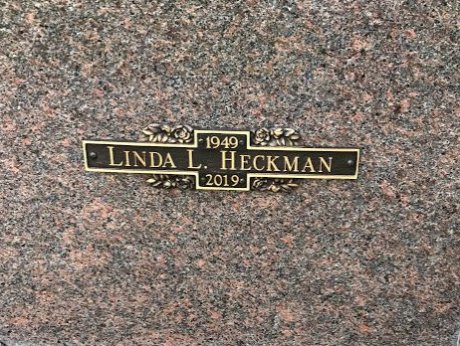
Photo by SMMR

Linda Heckman, 69, of Bluffton, passed away Monday morning, June 17, 2019, at her home. She was born on July 20, 1949 in Wells County, Indiana to Roger & Luella (Maller) Grogg. Linda graduated from Bluffton High School in 1967. She was an owner/operator, with her husband Bob, of Dale’s Auto & Truck Repair from 1984 to 2003. Linda worked at Walmart since 2004. Linda enjoyed crocheting, her plants and flowers, and spending time with her family.
On June 7, 1967, Linda married Robert “Bob” Heckman in Ports-mouth, Virginia. Bob preceded her in death on November 13, 2003.
Linda is survived by her children; Robert “Bobby” (Kathy Terlizzi) Heckman II, of Craigville, Christina “Tina” (Tim) Kleinknight, of Bluffton and Nathan “Nate” (Lisa) Heckman, of Markle, along with seven grandchildren and four great-grandchildren. She is also survived by her siblings; Sally (John) Perkins of Uniondale, Randy (Deb) Grogg of Fort Wayne, Karen (Jim) Vierling of Dundee, Florida and Mike Grogg. Linda is preceded in death by a brother, Dennis Grogg.
A service to celebrate Linda’s life will be held at 10:30 A.M. on Friday (June 21, 2019) at Thoma/Rich, Lemler Funeral Home in Bluffton with Jeff Lemler officiating. Entombment will follow at the Northridge Community Mausoleum located at Fairview Cemetery.
Calling will be held from 2 P.M. to 8 P.M. on Thursday at the funeral home, and for one hour prior to the service on Friday.
Memorials may be made to the Bluffton Fire Department or Visiting Nurse and Hospice Home.
Thoma/Rich Funeral Home, Wells County, Indiana
Tuesday, June 18, 2019

