Homer Mearl Harrison
July 24, 1934 – April 1, 1994

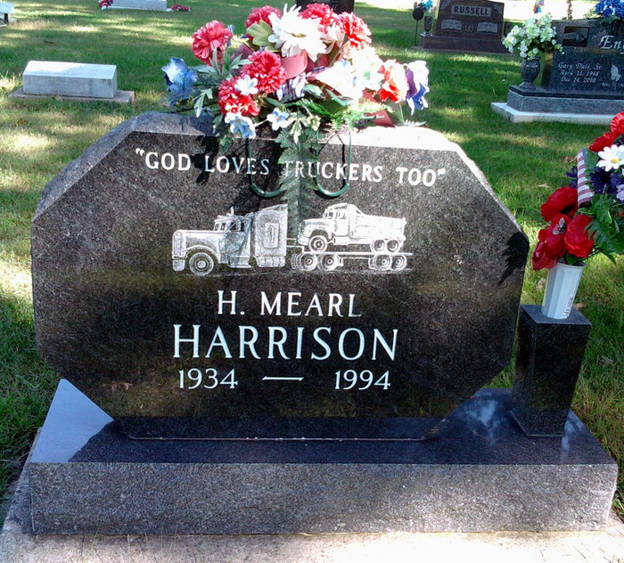
Photo by Thomas Liby
Homer M. Harrison, 59, 337 Mercer Ave., died at 12:35 p.m. Friday in Adams County Memorial Hospital's emergency room after suffering a heart attack at home earlier.
He was born on July 24, 1934 in Murfreesboro, Arkansas to Homer and Cleo Bell Harrison. His father is deceased; his mother lives in Bluffton. He married Sandra Hurt on May 4, 1961 and she also survives. He was a truck driver for 42 years for Moellering Construc-tion Co. in Fort Wayne and was a member of Teamsters' Local 414 in Fort Wayne.
Other survivors are two sons, Matthew Harrison, Decatur, and Michael Harrison, Indianapolis; two daughters, Mrs. Edward (Michelle) Olinger, Fritch, Texas, and Mrs. Kent (Mary Diane) Lehman, Bluffton; two sisters, Mrs. Dick (Mary) Knapp and Mrs. Daniel (Charlene) Lantz Jr., both of Bluffton; a brother, Jack Harrison, Fort Wayne and eight grandchildren. A brother, Norman Harrison, is deceased.
Funeral services will be at 1 p.m. Tuesday in Zwick-Sefton & Jahn Funeral Home, Decatur, with burial in Fairview Cemetery, Bluffton. Visiting hours are today until 5 p.m. and 7-9 p.m. Preferred memorials are to the donor's choice.

Decatur Daily Democrat, Adams County, Indiana
Monday, April 4, 1994

