Elizabeth “Betty” (Borne) Hansen-Tschannen
August 22, 1908 – October 19, 2003

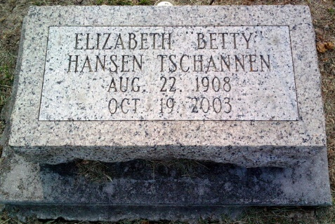
Photo by Thomas Liby

Elizabeth Borne “Betty” Tschannen, 95, died at 1:20 p.m. Sunday, Oct. 19, 2003 at the Christian Care Retirement Community. She had been in failing health the past three years. A native and life-long resident of Bluffton, she was born on Aug. 8, 1922 to Charles C. and Grace Andrew Borne.
Mrs. Tschannen was a member of the First United Methodist Church since 1921 and maintained an active participation, including serving as treasurer of the F.U.M. Women for many years. She was also very involved in the community, including an active membership in the Epsilon Zeta chapter of the Sigma Phi Gamma International Sorority, receiving her 50-year membership recognition in 1986. She has been a member of the Home Forum Extension Club since 1949 and was also a volunteer at the Wells Co. Historical Museum and the Wells Community Hospital Auxiliary Gift Shop. She was also a member and volunteer of the Wells Co. Council on Aging.
She was employed as a bookkeeper and clerk at a number of businesses during her career including Deam and Spivey Drug Store, H. Thoma & Son Furniture and Funeral Home, Hinkle’s Drug Store and the Kennedy Drug Store. She owned and operated the City News Stand on East Market St. from 1954 to 1966, worked at the Caylor-Nickel Clinic and Hospital and the Toll Gate Motel for several years. She also worked part-time as a correspondent at the News-Banner from 1976 to 1995.
Survivors include a daughter, Mrs. Ray (Elaine Jean) Hansen Gardiner of D’Iberville, Miss.; a step-son, Larry Tschannen of Bluffton; eight grandchildren; and nine great grandchildren.
She was preceded in death by her first husband, Stanley Hansen, who died in 1985; her second husband, Albert Anthony Tschannen, who died May 30, 1994; a son, James M. Hansen; and two sisters, Louise Archbold and Patricia Platt.
Calling hours are Tuesday from noon to 2 p.m. at the Thoma/Rich, Hewitt & Chaney Funeral Home. Services will be held Tuesday at 2 p.m. at the funeral home with Pastor Gary Lewis officiating. Burial will be in Fairview Cemetery. Preferred memorials to the church.

News Banner, Wells County, Indiana
Oct. 20, 2003

