Betty E. (Barley) Hankins
July 7, 1928 – September 19, 2011

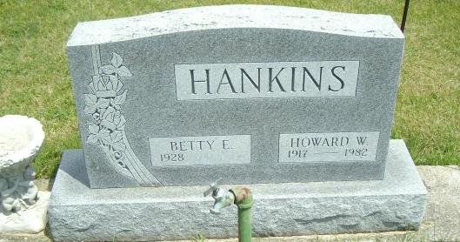
Photo by smalltown

Betty E. Hankins, 83, of Fort Wayne, died at 9:42 p.m. Monday, Sept. 19, 2011, at Parkview Hospital in Fort Wayne. Mrs. Hankins was born on July 7, 1928, in Marion to Ted and Sarah "Pauline" (Reed) Barley. She married Dozier C. Mills in 1950 and they were married until 1958. She married Joseph Hall in 1960; he preceded her in death 12 days after their marriage. She married Howard Hankins in 1961; he preceded her in death in 1982.
A 1947 graduate of Marion High School, she served in the United States Navy in the Korean War from 1949 to 1950. She played on the women's basketball team in the navy, scoring 47 points in one game. She was recruited to play for the All American Red Heads, but decided to start a family. She was a member of ladies baseball and basketball teams in Marion.
She worked at Corning Glass in Bluffton from 1968 to 1983. She was a former member of the American Legion Post 111 in Bluffton and the Bluffton Elks Lodge. She enjoyed drawing and always entered exhibits in the Bluffton Street Fair Art Show.
Surviving relatives include two daughters, Debra K. Mills of Ashley and Connie S. Mills-Hockenberry of Alabama; two brothers, William (Mary) T. Barley of Marion and James R. (Mary) Barley of Scottsburg; six grandchildren and five great-grandchildren.
Mrs. Hankins was also preceded in death by a sister, Jacqueline Barley.
Calling hours will be from 8:30 to 10:30 a.m. Friday, Sept. 23, at the Thoma/Rich, Chaney and Lemler Funeral Home in Bluffton. Funeral services will be at 10:30 a.m. Friday, at the funeral home, with Certified Funeral Celebrant Jeff Lemler officiating. Burial is at Fairview Cemetery, in Bluffton. Military graveside honors will be performed by the American Legion Post 111 and the United States Navy Honor Guard.
Preferred memorials are to the charity of the donor's choice.

Thoma/Rich, Lemler Funeral Home, Wells County, Indiana

