Richard Lee Hahn
July 22, 1938 – April 23, 2010

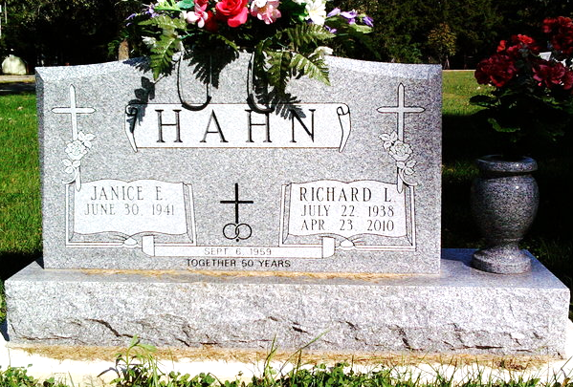
Photo by Thomas Liby

Richard Lee Hahn, 71, of Bluffton, died at 8:10 a.m. Friday, April 23, 2010, of complications from cancer. He had been in failing health since 2006. Mr. Hahn was a truck driver, having worked for several companies including Renners Express. After his retirement in 2001, he enjoyed working for Troyer's Foods in Berne.
He was a 1957 graduate of Chester Center High School and had resided in Bluffton for 55 years. He was a member of the Bluffton Elks Lodge and attended the Park United Brethren Church. He enjoyed gardening, canoeing, and watching Indiana University basketball. He was a loving husband, father, and grandfather. He will be missed by everyone who knew him.
Mr. Hahn was born July 22, 1938, in Middletown, Ohio, to William D. Hahn and Gladys Kincaid Hahn. He married Janice Guthrie Sept. 6, 1959, in Bluffton; the couple celebrated their 50th wedding anniver-sary in 2009. His wife survives in Bluffton. Also surviving are a daughter, Christy (Bernie) Stone of Fort Wayne; two sons, Gary (Cherie) Hahn of Bluffton and Greg (Suzi) Hahn of White Plains, Md.; two granddaughters, Samantha Stone and Alex Stone, both of Fort Wayne; and a sister, Margie (Ted) Johnson of Bluffton.
Calling will be from 2 to 8 p.m. Sunday and from 9:30 to 10:30 a.m. Monday at the Thoma/Rich, Chaney, and Lemler Funeral Home in Bluffton. Services will be held at 10:30 a.m. Monday at the funeral home with Pastor Larry Taylor officiating. Burial will be at the Fairview Cemetery in Bluffton.
Preferred memorials are to the Park United Brethren Church.

Thomas/Rich, Lemler Funeral Home, Wells County, Indiana

