Janice E. (Guthrie) Hahn
June 30, 1941 – November 18, 2021

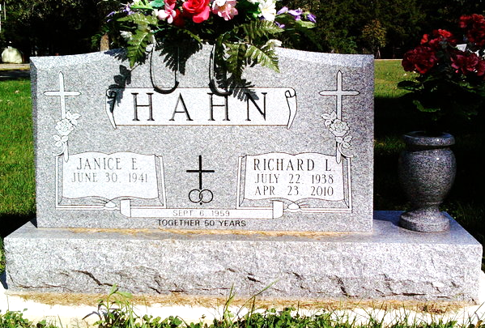
Photo by Thomas Liby

Janice (Guthrie) Hahn, 80, passed away with a peaceful smile at 9:30 a.m. on Wednesday, November 18, 2021. Janice was born on June 30, 1941 in Bluffton, Indiana and was a life-long resident of Wells County. Janice was a warm-hearted homemaker, mother, and grandmother. It would be an impossible feat to list the countless names of all the family, friends and neighbors whose lives were touched by her warmth and kindness. Jan was a devoted mother to her three surviving children Greg (Suzi) Hahn, Gary (Cherie) Hahn, and Christy (Bernie) Stone and a selfless Grandmother to her surviving Granddaughters Samantha (Samuel) Oren and Alexandria Stone.
Although she will be missed dearly, her family and friends are comforted that she is now reunited with her loved ones that preceded her in death, including her sister Judy Gish, parents Robert and Ellen Guthrie, and most of all her beloved Husband and best friend of 51 years, Richard Hahn.
A funeral service will take place at 11:00 A.M. Tuesday, November 23, 2021 at the Thoma/Rich, Lemler Funeral Home, with Rev. Lyle Breeding officiating. There will be calling prior to the service from 9:00 A.M. until the service time. Burial will follow at Fairview Cemetery.

Thomas/Rich, Lemler Funeral Home, Wells County, Indiana

