Ward Hayward Grove
September 28, 1878 – March 24, 1943

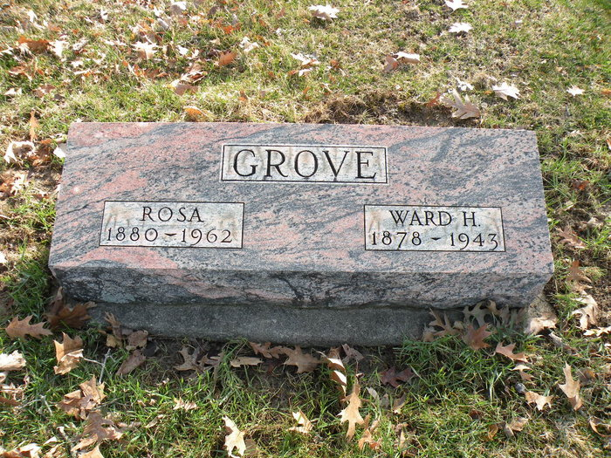
Photo by Darrell Wayne Grove

Indiana, U.S., Marriage Index, 1800-1941
Name Ward Grove
Marriage Date 13 May 1899
Marriage Place Wells, Indiana, USA
Spouse Name Rosa Brenner
**
U.S., World War II Draft Registration Cards, 1942
Name Ward Grove
Gender Male; Race White
Birth Date 28 Sep 1879 (sic)
Birth Place Wellsburg, Indiana, USA
Residence Place Wellsburg, Indiana, USA
Military Draft Date 1942
Next of Kin Mrs Rosa Grove
**
Ward Hayward Grove from tree HunterBevelhyer 031815
Birth 28 Sep 1879 Wells, Indiana, USA
Marriage 13 May 1899 Wells, York, Maine, USA
Residence 1942 Wells, Indiana, USA
Death 24 Mar 1943 Wells, Indiana, USA
Father John Thrap Grove (1839-1892)
Mother Ellen Elizabeth Moyer (1852-1940)
Spouse Rosa Braner (Born 1881)
45110 People 18 Records 18 Sources

