Rosa (Braner) Grove
Feb. 7, 1880 – February 17, 1962

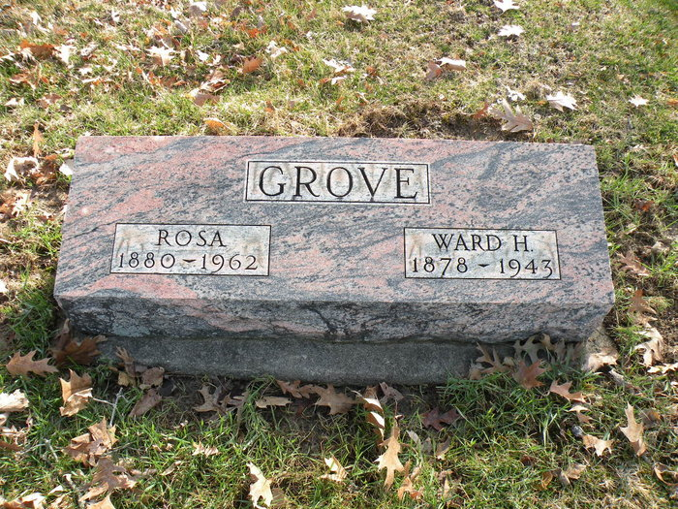
Photo by Darrell Wayne Grove

MOTHER OF DON GROVE DIES SATURDAY
RITES AT BLUFFTON ON TUESDAY FOR MRS. WARD GROVE, 82

Mrs. Ward (Rosa) Grove, 82, of Bluffton, mother of Don Grove, Berne police chief, died at 11:45 p.m. Saturday at the Davis Nursing home in Bluffton where she was a patient one year. She was a resident of Bluffton most of her life.
Mrs. Grove was born Feb. 7, 1880, the daughter of Joseph and Jane Tapp Braner and was married to Ward Grove on May 13, 1898. He is deceased.
Surviving are the following children; Lester Grove, Bluffton; Mrs. Howard McCormick, Bluffton; Hershel Grove, Bluffton; Mrs. Fred Ulmer, Sturgis, Michigan and Don Grove, Berne; a sister, Mrs. Harry Yocum, Bluffton R.R. and a brother, harry Braner, Marion. A brother and three sisters are deceased.
The body is at the Thoma Funeral home in Bluffton where friends may call until 12 noon Tuesday when it will be taken to the Epworth Methodist church, of which she was a member, for funeral services at 1:30 p.m. Rev. Keith Davis will officiate and burial will be in Fairview cemetery.

Berne Library Adams County, IN
Obits 1962-1964, image 3
Mon., Feb. 19, 1962

