Raymond Eugene Grimm
August 18, 1928 – April 23, 2009

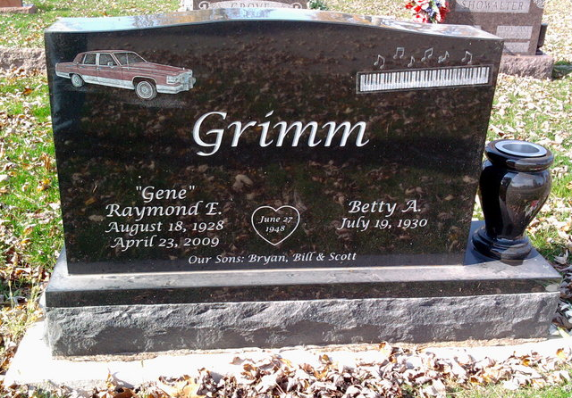
Photo by Thomas Liby

Raymond "Gene" Grimm, 80, of Berne, Indiana passed away at 12:30 a.m. Thursday, April 23, 2009 at his residence. Gene was born on August 18, 1928 in Wells County, Indiana the son of Howard and Adah (Hunt) Grimm, both deceased. He married Betty Jamison on June 27, 1948 and she survives.
Gene was a member of the Keystone United Methodist Church. He was a U.S. Army Veteran serving during the Korean Conflict from 1954 until 1956. Gene was co-owner of Grimm Auto Services for twenty-seven years and was a former Berne Cub Scout Leader. He enjoyed camping with his family and playing cards.
Gene is survived by his wife, Betty Grimm of Berne, Indiana; a son, Bryan (Dawn) Grimm of Berne, Indiana; a son, William "Bill" (Becky) Grimm of Berne, Indiana; a son, Scott Grimm of Missouri; and a sister, Evelyn (James) Bates of Huntington, Indiana. Other survivors include four grandchildren, Cody, Dylan, Keirstyn, and William Grimm.
Funeral services will be held at 2:00 p.m. Sunday, April 26, 2009 in the Yager-Kirchhofer Funeral Home in Berne, Indiana with the Pastors Marlene Ellis and Keith Rupp officiating. Interment will be in the Fairview Cemetery of Bluffton, Indiana. Military Graveside services will be conducted by the Berne American Legion Post #468. Family and friends will be received from 2:00 – 8:00 p.m. Saturday, April 25, 2009 in the Yager-Kirchhofer Funeral Home in Berne and one hour prior to the funeral service at Yager-Kirchhofer on Sunday.
Preferred memorials are to Family Hospice of Northeast Indiana or the Keystone United Methodist Church.

Yager-Kirchhofer Funeral Home, Adams County, Indiana

