Betty A. (Jamison) Grimm
July 19, 1930 — December 26, 2024

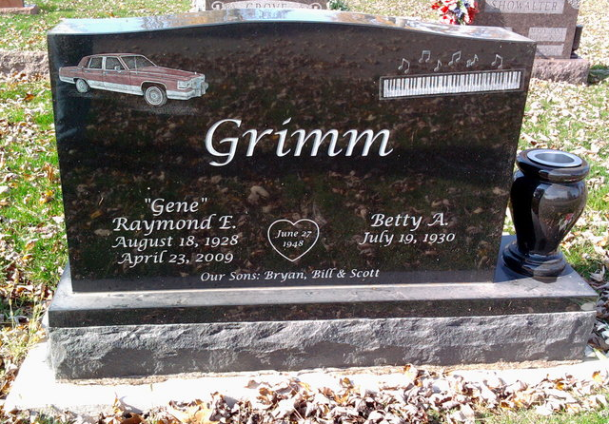
Photo by Thomas Liby

Betty A. Grimm, 94, of Berne, Indiana passed away Thursday morning, December 26, 2024, at Swiss Village in Berne. She was born on July 19, 1930, in Bluffton, Indiana to the late Glen W. and Clara Deane (Markley) Jamison. Betty was united in marriage to Raymond E. “Gene” Grimm on June 27, 1948, and Gene preceded her in death on April 23, 2009.
Betty attended Poneto Baptist Church in Poneto, Indiana, and was a former member of Keystone United Methodist Church until its closing. She served her family as a homemaker and was a music teacher teaching numerous students for over 70 years. Betty also served several years on the Adams County EMS.
Betty was talented and enjoyed sewing and quilting. She enjoyed friendly competition playing cards and numerous other games. Summers at Jellystone Park created many lasting memories for her and her family.
She is survived by her son, Bryan Grimm of Berne, Indiana; son, Bill (Becky) Grimm of Berne, Indiana; four grandchildren, Cody (Rachel) Grimm, Dylan Grimm, Keirstyn Grimm-Shane, and William Grimm; and four great-grandchildren, Laken Shane, Hensley Shane, Aria Shane, and Tanner Shane.
Betty was preceded in death by her son, Scott Grimm; and sister, Joyce C. Jamison in infancy.
A funeral service will be held at 10:00 a.m. Tuesday, December 31, 2024, at the Zwick & Jahn Funeral Home, Yager-Kirchhofer Chapel in Berne, Indiana with Pastor Dan Sommer officiating. Burial will follow at Fairview Cemetery in Bluffton, Indiana. The family will receive friends from 4:00 to 7:00 p.m. Monday, December 30, 2024, at the Zwick & Jahn Funeral Home, Yager-Kirchhofer Chapel in Berne, Indiana, and one hour prior to the service at the funeral home on Tuesday.
Preferred memorials can be given to the Berne Volunteer Fire Department.

Zwick & Jahn Funeral Home, Adams County, Indiana
December 30, 2024

