Tommy L. Gregg
August 26, 1929 – February 17, 1980

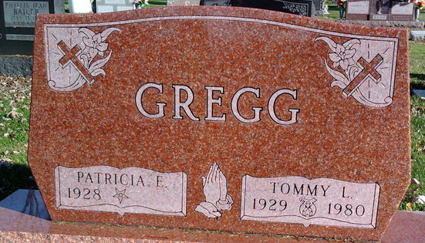
Photo by Annie (Kunkel) Hoffmeier

Tommy L. “Tom” Gregg, 50, of 6730 Winnebago Drive died at 10 am Sunday at his home. Mr. Gregg, a native of Wells County, had lived in Fort Wayne since 1957. He was account executive and part owner of PM Indiana Inc. 20 years. He was a member of the Fort Wayne Chapters of the national and Indiana societies of public accountants.
Surviving are his wife, Patricia; a son, David A. of Bloomington; his father, David of Bluffton; two brothers, Rex of Bluffton and Patrick of Munising, Mich.; and a sister, Bonnie Hoy of Yorktown.
Friends may call from 3 to 9 pm today at D.O. McComb & Sons Lakeside Park Funeral Home, where Summit City Lodge, 170, F&AM, will conduct services at 7:30 pm. The body will then be sent to Thoma-Rich Funeral Home, Bluffton for services at 1:30 pm Wednesday and calling from 2 to 9 pm Tuesday. Burial will be in Fairview Cemetery, Bluffton.
Preferred memorials are gifts to the Shriners’ Crippled Children’s Hospital and the Masonic Home, Franklin.
Journal-Gazette, Allen County, Indiana
February 18, 1980
Page 2A

