Patricia E. (Carpenter) Gregg
September 3, 1928 – August 29, 2018

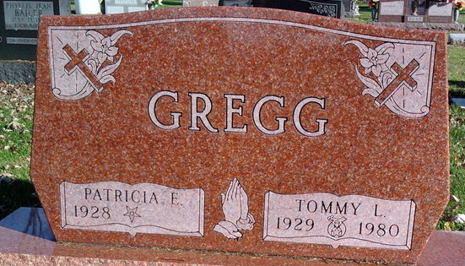
Photo by Annie (Kunkel) Hoffmeier

Patricia "Pat" E. Gregg, 89 of Fort Wayne, IN passed away August 29, 2018. She had been the Office Manager for Dental Office for 54 years. She was a life member of Isaac Knapp Society, Indiana State and American Dental Association, Eastern Star Chapter# 432, Past Member Shriners Widow Club and Daughter of the Nile.
Pat was survived by her son, David Gregg, grandson, Tomas
Gregg and sister, Judy Carpenter. She is preceded in death by her husband, Tommy L. Gregg, parents, Harry and Marguerite (Berger) Carpenter, brother, Harold Carpenter and sister, Shirley Krinn.
Services will be held Wednesday, September 5, 2018 11 AM at St. Joseph United Methodist Church 6004 Reed Road Fort Wayne, IN with visitation Tuesday, September 4th 6-8 PM at D.O. McComb & Sons Funeral Home-Maplewood Park 4017 Maplecrest Road Fort Wayne, IN. There will be an Order of the Eastern Star memorial service conducted at 7 PM during the visitation. Additional visitation will be held one hour prior to the service on Wednesday at the church. Burial will take place at the Fair View Cemetery in Bluffton, IN at 3PM.
In lieu of flowers memorial gifts may be made to, Shrine Children's Hospital, St. Joseph United Methodist Church or Parkview Foundation.

D.O. McComb & Sons Funeral Home
August 31, 2018

