Frank G. Gregg
January 9, 1912 – December 20, 1974

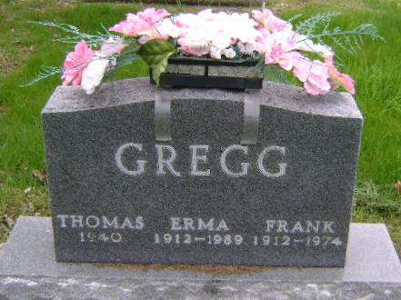
Photo by Bruce Sonner

Indiana, U.S., Birth Certificates, 1907-1940
Name: Frank Gregg
Gender: Male
Birth Date: 9 Jan 1912; Birth Place: Liberty, Wells, Indiana, USA
Father: Thomas D Gregg
Mother: Ida I Morris
Certificate Number: 50432; Roll Number: 40474_357982
Volume Range: 595 - 59a
**
Michigan, U.S., Death Index, 1971-1996
Name: Frank G Gregg
Birth Date: 9 Jan 1912
Death Date: 20 Dec 1974
Gender: Male
Residence: Gilead, Branch, Michigan
Place of Death: Gilead, Branch, Michigan

