Erma Detta (Deam) Gregg
August 26, 1912 – September 5, 1989

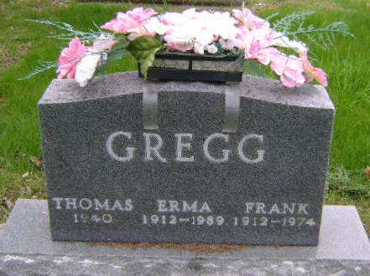
Photo by Bruce Sonner

U.S., Social Security Applications and Claims Index, 1936-2007
Name: Erma Deetta Gregg [Erma D Gregg] [Erma Deetta Deam]
Gender: Female
Race: White
Birth Date: 26 Aug 1912
Birth Place: Bluffton Wel, Indiana
Death Date: 5 Sep 1989
Father: Earl R Deam
Mother: Nellie M Beaty
SSN: xxx
Death Certificate Number: 00000000000000000000053155
Notes: Mar 1962: Name listed as ERMA DEETTA GREGG; 22 May 1998: Name listed as ERMA D GREGG
**
Michigan, U.S., Death Index, 1971-1996
Name: Erma D Gregg
Birth Date: 26 Aug 1912
Death Date: 5 Sep 1989
Gender: Female
Residence: Kalamazoo, Kalamazoo, Michigan
Place of Death: Kalamazoo, Kalamazoo, Michigan
Contributor: Ted Smith (46928243) • tcsmith@gmx.com

