Bertha (Gehrett) Gottschalk French
November 19, 1880 – September 18, 1972

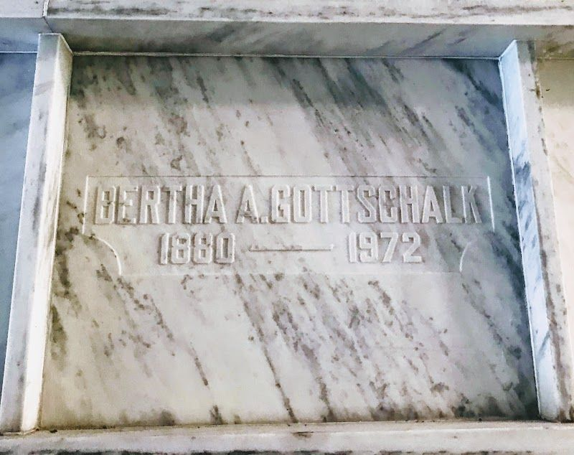
Photo by SMMR

French, Mrs. Bertha Gottschalk, 91, of 922 South Main St., died today at Community Hospital, Born in Nottingham Twp. Nov 19 1880, she was a daughter of Samuel and Mary Henley Gehrett, Her first marriage was to William Andrew Gottschalk, who died May 22, 1946, and a second marriage to Fred French who died July 30 1949.
The last of her family, she was a member of the Past Noble Grand of the Rebekah Lodge and of the Reiffsburg United Methodist Church.
Services will be Wednesday at Thoma Funeral Home with Rev. Robert Jackson and Rev. Tillman Nussbaum Officiating, The
body was entombed in the Fairview Mausoleum

Unnamed newspaper clipping
Sept. 18, 1972

