Homer Charles Goodin
June 8, 1886 – December 8, 1975

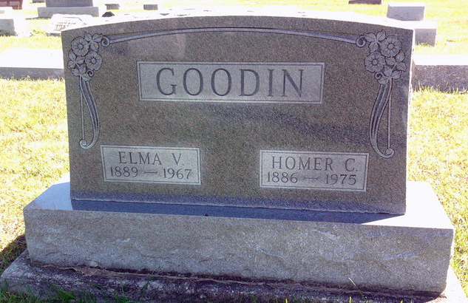
Photo by Thomas Liby

Homer Charles Goodin, 89, a former grocer in Decatur, died at 7:45 a.m. Monday at the Methodist Memorial Home in Warren following a long illness. He resided there for five years.
Mr. Goodin managed grocery stores in Berne, Bluffton and Decatur. He operated a Hoosier Store in Berne and later the Kroger store for many years. He owned and operated a grocery on N. Second St. in downtown Decatur a number of years ago.
He was a member of the Cross United Church in Berne.
He was born in Nottingham, Ind., on June 8, 1886, the son of Samuel A. and Rosa Mortiz-Goodin and married Elma Ashbaucher on May 12, 1919, and she preceded him in death on June 6, 1967.
Survivors include one son, James Goodin, Gremont; two stepdaughters, Mrs. Don (Mary) Speicher, Berne, and Mrs. Grover (Betty) Moser, San Bruno, Calif.; one sister, Mrs. Mary Steppy, Orlando, Fla.; five grandchildren and one great-grandchild.
Funeral services will be held at 1:30 p.m. Wednesday in the chapel of the Methodist Memorial Home in Warren, where friends may call after 2 p.m. today. Rev. Don Jennings and Rev. Wilson Bixler will officiate and burial will be in Fairview Cemetery at Bluffton.

Decatur Daily Democrat, Adams County, Indiana
Tuesday, Dec. 9, 1975

