Elma V. (Ashbaucher) Goodin
December 1, 1889 – June 6, 1967

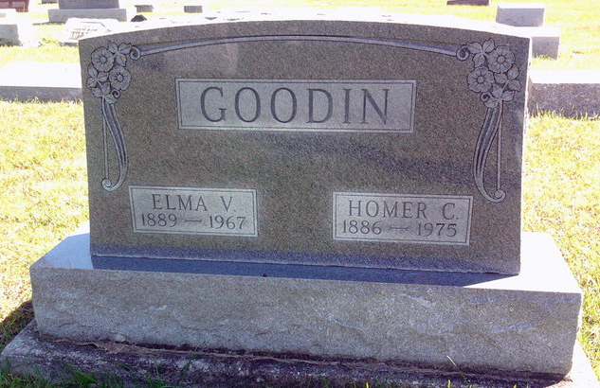
Photo by Thomas Liby

Indiana, U.S., Death Certificates, 1899-2017
Name Elma V Goodin
[Elma V Ashbaucher]
Gender Female
Race Caucasian (White)
Marital Status Married
Age 77
Birth Date 1 Dec 1889
Birth Place Indiana
Death Date 6 Jun 1967
Death Place Decatur, Adams, Indiana, USA
Death Registration Date 1967
Father Peter Ashbaucher
Mother Mary Luginbill
Spouse Homer Goodin, informant
Burial 6/9/1967 Fairview Cemetery

