Margaret Ann (Hogg) Glasgow
April 9, 1879 – February 28. 1973

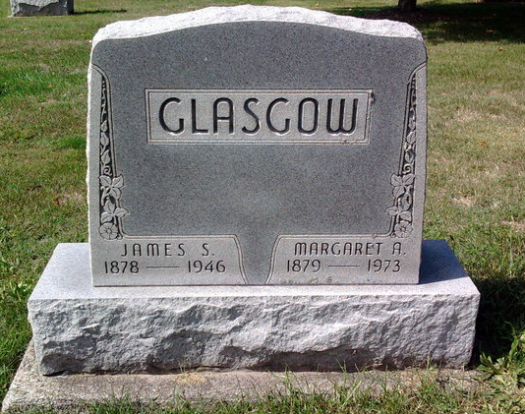
Photo by Thomas Liby

Mrs. James S. (Margaret) Glasgow, 93, died Wednesday at the Davis Nursing Home, Bluffton. Born April 9, 1879 in Rockcreek Township, she was a daughter of John and Annie Torens Hogg. Her marriage to Mr. Glasgow, who died December 23, 1946, took place February 2, 1910.
Surviving are four sons, John of Pleasant Lake, Leslie of Baton Rouge, Louisiana, James of Route 1, Bluffton and Paul of Portland; two stepchildren, Mrs. Donald (Florence) Peregrine of Hamlet and Hugh Glasgow of Route 1, Bluffton; 11 grandchildren and nine great grandchildren.
Services will be Friday at the Thoma Funeral Home with Rev. Philip Hazelton officiating; burial in Fairview Cemetery.
Wells County Indiana Obituaries
1969 - 1975

