James Scott Glasgow
October 19, 1878 – December 23, 1946

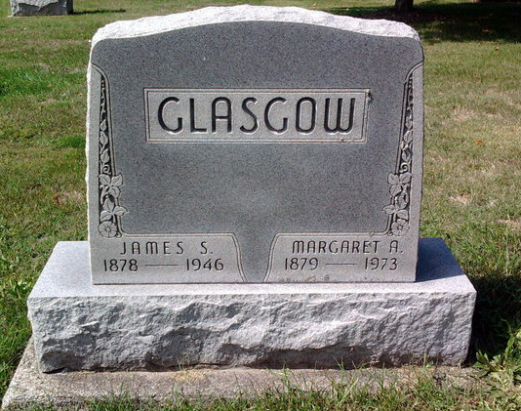
Photo by Thomas Liby

Baird Funeral Home Records (1946-1948)

Date of Entry | Year 1946
Name of Deceased | James S. Glasgow
Residence | Pike Tp.
Spouse | Margaret Glasgow
Address | Bluffton
Occupation | Farmer
Date of Death | December 23, 1946; 5:15 p.m.
Date of Birth | October 19, 1878
Age | 68 years, 2 months, 4 days
Date of Funeral | December 26, 1946; 1 p.m.
Services At | Chapel
Clergyman | Rev. Perry
Birthplace | Idaville, Ind.
Place of Death | Residence
Certifying Physician | Engle
Name of Father | Samuel Glasgow
His Birthplace | Ohio
Maiden Name of Mother | Elizabeth Stipps
Her Birthplace | Ohio
Size of Casket | Metal 1/2
Manufactured By | Aurora
Cemetery | Fairview, Bluffton, Indiana

