Marie (Brickley) Girod
December 8, 1892 – September 28, 1967

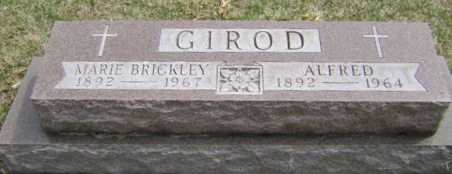

RITES SUNDAY FOR MRS. MARIE GIROD
Services will be held at 2 pm Sunday at the McBride Funeral Home for Mrs. Marie Girod, 74, of Bluffton Route 1, widow of Alfred Girod. Ill for the past two years and bedfast for six months, she died Thursday at her home.
A daughter of Thomas J. and Minnie Mosure Brickley, she was born Dec. 8, 1892 in Rockcreek Twp. Her marriage to Mr. Girod, who proceded her in death in 1964, took place Feb. 24, 1923 in Bluffton.
A lifelong resident of this county, Mrs. Girod was a member of the First United Church of Christ and the American Legion Auxiliary. She taught 12 years at Murray, Lancaster and Rockcreek Schools and in the following years tutored handicapped children. Mrs. Girod was instrumental in forming the Opportunity School and was its first principal for 4 1/2 years.
A member of the Library Board from 1938 through 1964, she served three years as county president of the Home Economics Clubs. Mrs. Girod was involved in many community activites, for which she received the Community Service Award at the 1966 Fish Fry.
Survivors include four daughters: Mrs. Dwight (Hallie) Pace and Mrs. Jack (Jean) Kober, both of Liberty Center Route 1, Mrs. Brooks (Joyce) Grandlienard of Bluffton Route 1 and Mrs. Lex Dormire of Uniondale; one son Dr. Don Girod of Indianapolis and 17 grandchildren.
Friends may call after 7 pm today at the funeral home. Rev. Calvin Ley will officiate at the services on Sunday. Burial will be in the Fairview Cemetery.

Unknown source

