Alfred Girod
September 4, 1892 – May 22, 1964

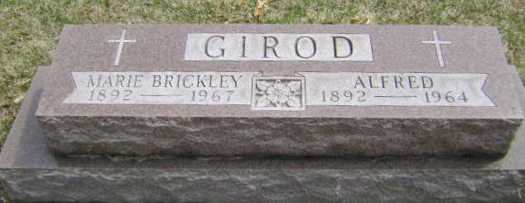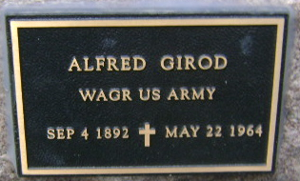

ATTACK FATAL TO ALRED GIROD, 71
Alfred Girod, 71, of Bluffton Route 1 at 7 pm Friday at Wells County Hospital following a two week illness. Death was attributed to a heart attack.
Born Sept. 4, 1892 in Adams County, he was the son of Peter and Louise Allman Girod. His marriage Feb. 24, 1923 in Bluffton was to Marie Brickley, who survives. A member of First United Church of Christ and American Legion Post 111, Mr. Girod served in France during World War I. He was a lifelong resident of Wells County and farmed northwest of Bluffton.
Surviving in addition to the wife, are four daughters: Mrs. Dwight (Hallie Marie) Pace and Mrs. Jack Kober, both of Liberty Center Route 1, Mrs. Brooks (Joyce) Grandlienard of Bluffton, Route 1, and Mrs. Lex (Ina Mae) Dormire of Uniondale, and one son, Dr. Don Girod of Minneapolis, Minn. Also surviving are three sisters: Mrs. Joe (Mary) Loganville of Fort Wayne, Mrs. Claude (Lucinda) Kindel of Orange City, Fla., and Mrs. Weaver (Della) McFarren of Sacramento, Calif. Two brothers, Samuel of Berne rural route and Robert of Bluffton Route 4 and 16 grandchildren.
Friends may call at the McBride Funeral Home. Services will be held Monday at First United Church of Christ with Rev. Ralph Koch officiating. Burial will be in Fairview Cemetery.

Unknown source
**

Funeral Held Today For Alfred Girod

Funeral services were held this afternoon at the First United Church of Christ in Bluffton route 1, for Alfred Girod, who died Friday night at the Wells county hospital following a heart attack.
He was born in Adams county Sept. 4, 1892, a son of Peter and Louise Allman-Girod, and was married to Marie Brickley Feb. 24, 1923. Mr. Girod was a member of the First United Church of Christ and American Legion Post 111.
Surviving are his wife; four daughters, Mrs. Dwight Pace and Mrs. Jack Kober, both of Liberty Center route 1, Mrs. Brooks Grandlienard of Bluffton route 1, and Mrs. Lex Dormine of Uniondale; one son, Dr. Don Girod of Minneapolis, Minn., three sisters, Mrs. Joe Luginbill of Fort Wayne; Mrs. Claude Kindel of Orange City, Fla., and Mrs. Weaver McFarren of Sacramento, Calif., two brothers, Samuel of near Berne, and Robert of Bluffton route 4, and 16 grandchildren.

Berne (IN) Library Heritage Room
Adams County Obits 1962-1964
Mon. May 25, 1964

