Jerry C. Gillum
March 14, 1933 – April 26, 2018

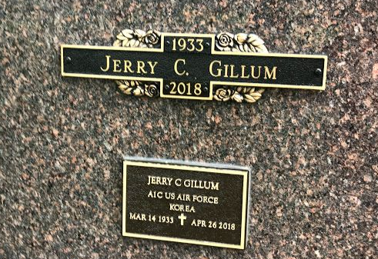
Photo by SMMR

Jerry C. Gillum, 85, a Bluffton resident, went to be with his Lord on Thursday evening, April 26, 2018, at Heritage Pointe in Warren.
Jerry was born on March 14, 1933 in Portland, Indiana to Carl & Thelma (Girton) Gillum. He graduated from Pennville High School in 1952, where he was on the basketball team. He honorably served our country in the United States Air Force from 1952 to 1956, during the Korean War. Jerry worked at Kreesges Distribution in Fort Wayne for 35 years, retiring in 1992 and is a longtime member of Hope Missionary Church in Bluffton. On May 11, 1957 in Bluffton, Jerry married his high school sweetheart, Barbara (Petro) Gillum.
Survivors include his wife of 61 years, Barbara along with children; Tamara (Donny) Wall of Huntington, Jeffrey Gillum of Lancaster, Ohio, Michael (Karen) Gillum of Yoder and Tonya (Ed) Birkey of Leo, along with 6 grandchildren and 6 great-grandchildren and a sister Iris (Chuck) Wilson of Fort Wayne.
Jerry is preceded in death by his parents and two brothers, Doug & Paul Gillum.
Funeral Services for Jerry will be held at 10:30 A.M. on Tuesday (May 1st) at Hope Missionary Church in Bluffton. Pastors Gary Aupperle & Matt Hartsell will officiate. Entombment will follow at the Northridge Mausoleum at Fairview Cemetery in Bluffton, with military honors by the American Legion Post #111 of Bluffton and the United States Air Force Honor Guard. Calling hours will be held from 10 to 12 Noon on Monday in the Foltz Room at Heritage Pointe in Warren and from 2 to 8 on Monday at the Thoma/Rich, Lemler Funeral Home in Bluffton, and for one hour prior to the service at the church.
Memorials may be made to Heritage Pointe or DAV – Disabled American Veterans.
Thoma/Rich, Lemler Funeral Home, Wells County, Indiana
April 27, 2018

