Barbara June (Petro) Gillum
September 16, 1935 – August 25, 2020

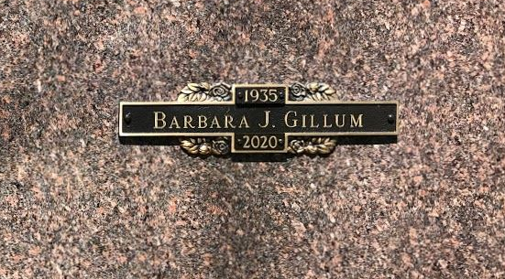
Photo by SMMR

Barbara June Gillum, 84, of Warren, a former resident of Bluffton, went to be with her Lord Tuesday evening, Aug. 25, 2020, at Heritage Pointe in Warren. Barbara was born Sept. 16, 1935, in Richmond, Ind., to Irl Walker and Wilma Petro Walker.
She graduated from Pennville High School. She received her Associates in Nursing from Northwestern in Chicago, and received her Bachelor of Science in Nursing at Purdue-Fort Wayne. Barbara worked as a registered nurse and director of education at Caylor-Nickel for 38 years. Barbara was a longtime member of Hope Missionary Church.
On May 11, 1957, in Bluffton, Barbara married her high school sweetheart, Jerry C. Gillum. Together they shared 61 years of marriage, until his death April 26, 2018.
She enjoyed camping, reading, crossword puzzles, and being with her friends from Hope Church.
Survivors include her children; Tamara (Donny) Wall of Huntington, Jeffrey Gillum of Lancaster, Ohio, Michael (Karen) Gillum of Florida, and Tonya (Ed) Birkey of Leo, along with six grandchildren and eight great-grandchildren.
Barbara is preceded in death by her parents and her husband, Jerry.
Funeral services for Barbara will be held at 10 a.m. Monday, Aug. 31, at Hope Missionary Church in Bluffton. Pastor Gary Aupperle will officiate. Entombment will follow at the Northridge Mausoleum at Fairview Cemetery in Bluffton. Calling hours will be from 4 to 7 p.m. Sunday, Aug. 30, at the Thoma/Rich, Lemler Funeral Home.
Memorials may be made to Heritage Pointe or Alzheimer's Association.
The safety of the family and all visitors is our utmost priority. For everyone's safety, we ask that you practice social distancing. Masks are required for visitation and for Barbara's service at the church. We appreciate your cooperation and patience.
Thoma/Rich, Lemler Funeral Home, Wells County, Indiana
August 28, 2020

