Thomas P. Gatto, Jr.
April 7, 1939 – January 8, 2007

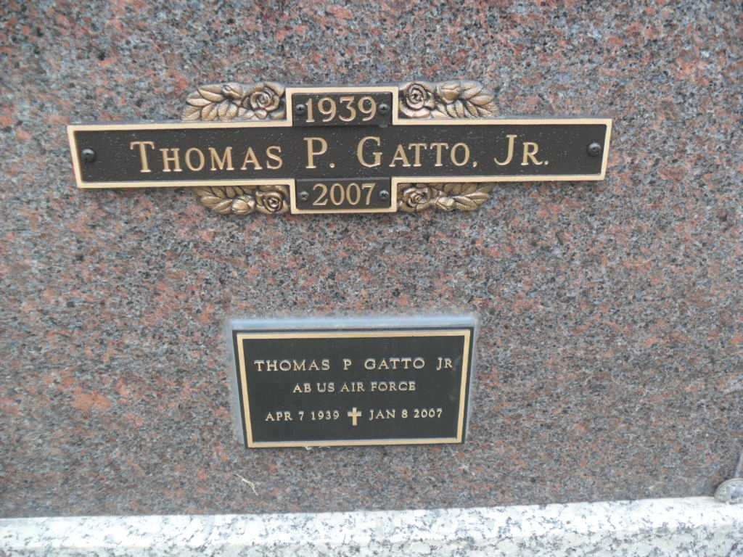
Photo by Pretty Little Grave Seekers

Thomas P. “Tom” Gatto Jr., 67, of rural Poneto passed away at 5:50 p.m. Monday, Jan. 8, 2007, at home with his family. He had been in failing health the past nine months.
Mr. Gatto had been vice president of Production Products Corporation for six years in Chittenango, N.Y. He worked for United Technology for 21 years, retiring in 2000.
An Army and Air Force veteran, he was a member of American Legion Post #111. He had resided in Wells County since 1995.
Born on April 7, 1939, in Worcester, Mass., he was a son of Thomas P. and Doris (Elderdge) Gatto Sr. His mother survives and resides in Worcester. His marriage in 1969 in Springfield, Mass., was to Florence (Lemieux), who survives.
Other survivors include children Julie Pignone of California, Lisa Penrod, Tammy Gatto and Kim Billington, all of Montpelier, Amanda Gatto of Poneto, Michael Lemieux of New York, David Lemieux of Ohio and Thomas Beccheria of Bluffton; three sisters, Mary Carter, Barbara Gatto and Karen Gatto, all of Massachusetts; 15 grandchildren; and five great-grandchildren. He was preceded in death by two brothers.
Calling is from 2 to 8 p.m. Thursday at Thoma/Rich, Hewitt & Chaney Funeral Home. Services are at 10:30 a.m. Friday at the funeral home with Pastor Bud Abrams officiating.
Burial will be in the Northridge Mausoleum at Fairview Cemetery with military graveside rites by American Legion Post #111. Preferred memorials are to the American Cancer Society
Thoma/Rich, Lemler Funeral Home, Wells County, Indiana
January 9, 2007

