Florence A. Gatto
July 12, 1943 – May 19, 2014

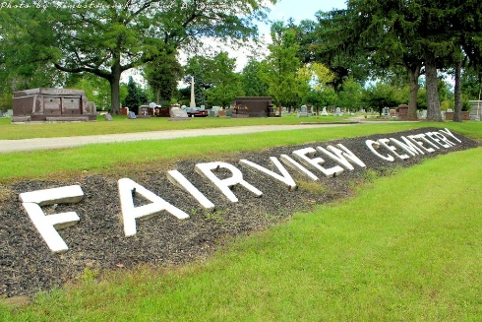
Photo by Tombstoner & Family

Florence A. Gatto, 70, of Bluffton, died at 5:35 a.m. Monday, May 19, 2014, at the Bluffton Regional Medical Center. Mrs. Gatto worked as a certified nursing assistant at Swiss Village in Berne for 10 years. She also owned and operated her own beauty shop, Door to Beauty, in Massachusetts. She was a machine operator at United Technologies in Massachusetts for more than 20 years. In addition, she also owned Gatto's Family Restaurant in Chittenango, N.Y.
She was born July 12, 1943, in Springfield, Mass., to Alice Lassor Waiter. She married Thomas P. "Tom" Gatto Jr. in 1969 in Springfield, Mass.; her husband preceded her in death Jan. 8, 2007.
Survivors include her children, Lisa (Todd) Penrod of Montpelier, Tammy (Sonny) Harrison of Bluffton, Kim (Chad) Billington of California, Amanda Gatto of Poneto, Michael (Donna) Lemieux of New York, and David Lemieux of Bluffton; 16 grandchildren and 12 great-grandchildren; and a sister, Francis Levasque of Massachusetts.
Services will be held at 3 p.m. Thursday, May 22, at the Northridge Mausoleum at Fairview Cemetery, where she will be interred. Pastor Les Cantrell will officiate at the ceremony.
Preferred memorials are to the Susan G. Komen for the Cure, an organization committed to finding a cure for breast cancer.
Thoma/Rich, Lemler Funeral Home, Wells County, Indiana

